

**SRI VENKATESWARA COLLEGE OF ENGINEERING**

**& TECHNOLOGY(AUTONOMOUS)**

**TOPIC ON:**

Customer Relationship Management

(CRM) System

CSE DEPARTMENT

**TEAM MEMBERS LIST:**

**P. RESHMA (22781A05A8)**

**P. JASMIKA (22781A05B3)**

**P. SHIHANULLA (22781A05B4)**

**P. MANVITHA (22781A05B6)**

**P.SRISHAIL (22781A05B8)**

**Customer Relationship Management (CRM) System:**

**Create Contacts:**

CREATE TABLE Contacts (

ContactID INT PRIMARY KEY AUTO_INCREMENT,

FirstName VARCHAR(50) NOT NULL,

LastName VARCHAR(50) NOT NULL,

Email VARCHAR(100) UNIQUE,

Phone VARCHAR(15),

Address VARCHAR(255),

City VARCHAR(100),

State VARCHAR(100),

ZipCode VARCHAR(10),

Country VARCHAR(50)

);

**desc Contacts;**

**Output:**

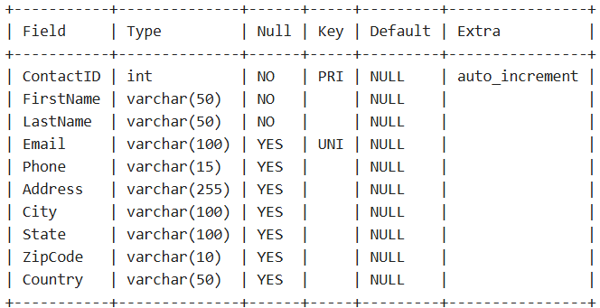

**Create Leads:**

CREATE TABLE Leads (

LeadID INT PRIMARY KEY AUTO_INCREMENT,

ContactID INT,

Source VARCHAR(100),

Status VARCHAR(50) CHECK (Status IN ('New', 'Contacted', 'Qualified', 'Lost', 'Converted')),

CreatedDate DATE,

LastContactDate DATE,

FOREIGN KEY (ContactID) REFERENCES Contacts(ContactID)

);

**desc Leads;**

**Output:**

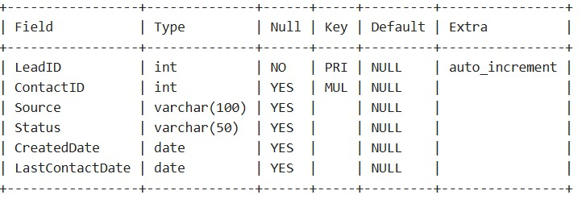

**Create Opportunity :**

CREATE TABLE Opportunity (

OpportunityID INT PRIMARY KEY AUTO_INCREMENT,

ContactID INT,

Name VARCHAR(100),

Stage VARCHAR(50),

Amount DECIMAL(10, 2),

ExpectedCloseDate DATE,

FOREIGN KEY (ContactID) REFERENCES Contacts(ContactID)

);

**desc Opportunity;**

**Output:**

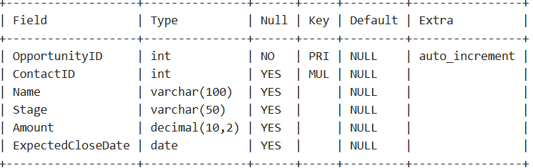

**Create Activity:**

CREATE TABLE Activity (

ActivityID INT PRIMARY KEY AUTO_INCREMENT,

ContactID INT,

Type VARCHAR(50),

Date DATE,

Notes TEXT,

FOREIGN KEY (ContactID) REFERENCES Contacts(ContactID)

);

**desc Activity;**

**Output:**

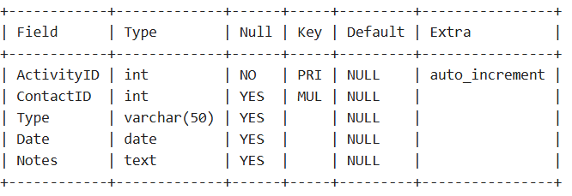

Insert contacts table:

INSERT INTO Contacts (FirstName, LastName, Email, Phone, Address, City, State, ZipCode, Country)

VALUES

('posa', 'chandana', 'chandanaposa@03.com', '8129345167', 'sai nagar', 'anantapur', 'andhra pradesh', '523402', 'india'),

('vaka', 'nandini', 'nandinivaka@02.com','6321923471', 'kavali', 'nellore', 'andhrapradesh', '517002', 'india'),

('purini', 'lavanya', 'lavanyapurini@08.com','6217936250', 'sapthagiri circle', 'hyderabad', 'telengana', '517230', 'india'),

('kuraparthi', 'yaswanthi', 'kuraparthiyaswanthi@04.com','6213472819', 'murkambattu', 'chittoor', 'andhrapradesh', '512934', 'india'),

('murramreddy', 'thanuja', 'thanujareddy@02.com','6324571321', 'badhvel', 'kadapa', 'andhrapradesh', '516423', 'india');

**select*from Contacts;**

**Output:**

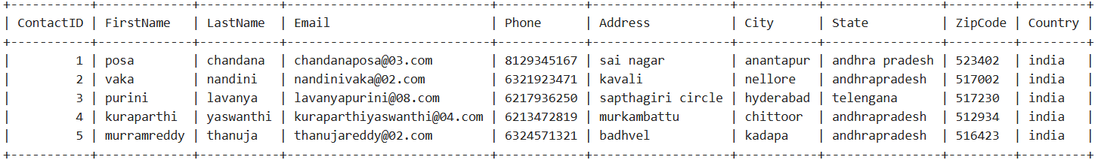

**Insert Leads table:**

INSERT INTO Leads (ContactID, Source, Status, CreatedDate, LastContactDate)

VALUES

(1, 'Website', 'New', '2024-11-23', '2024-11-23'),

(2, 'Referral', 'New', '2024-11-22', '2024-11-22'),

(3, 'Social Media', 'Contacted', '2024-11-21', '2024-11-23'),

(4, 'Email Campaign', 'Qualified', '2024-11-20', '2024-11-23'),

(5, 'Event/Trade Show', 'Lost', '2024-11-18', '2024-11-19');

**select*from Leads;**

**Output:**

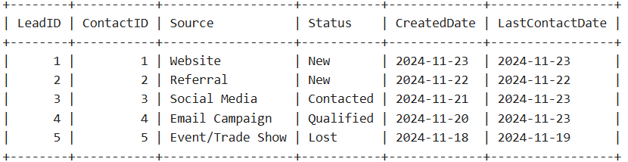

**Insert Opportunity table:**

INSERT INTO Opportunity (ContactID, Name, Stage, Amount, ExpectedCloseDate)

VALUES

(1, 'Big Deal', 'Qualification', 50000.00, '2024-12-15'),

(2, 'Small Deal', 'Proposal', 15000.00, '2024-12-10'),

(3, 'Partnership Agreement', 'Negotiation', 35000.00, '2024-12-20'),

(4, 'Exclusive Contract', 'Closed Won', 100000.00, '2024-11-30'),

(5, 'Long-Term Agreement', 'Prospecting', 25000.00, '2025-01-10');

**select*from Opportunity;**

**Output:**

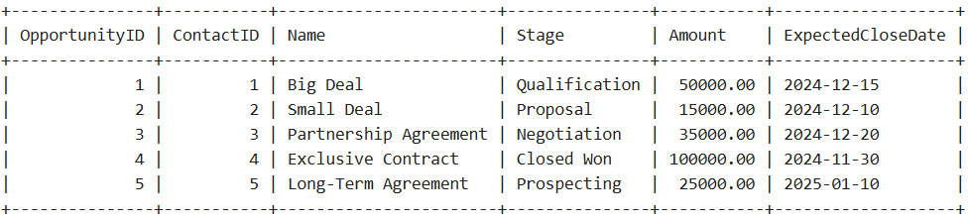

**Insert Activity table:**

INSERT INTO Activity (ContactID, Type, Date, Notes)

VALUES

(1, 'Call', '2024-11-23', 'Discussed product features and next steps'),

(2, 'Email', '2024-11-22', 'Sent follow-up email with pricing details and proposals'),

(3, 'Meeting', '2024-11-21', 'Met in person to discuss contract terms and project scope'),

(4, 'Call', '2024-11-20', 'Called to clarify project timeline and set new deadlines'),

(5, 'Email', '2024-11-19', 'Sent email regarding product availability and upcoming promotions');

**select*from Activity;**

**Output:**

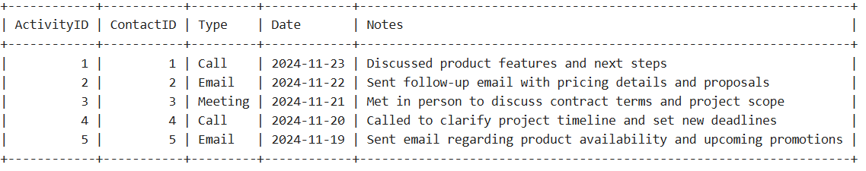

**SQL queries :**

**For Contacts:**

**1.Select All Contacts:**

To view all the contacts in the table:

SELECT * FROM Contacts;

Output:

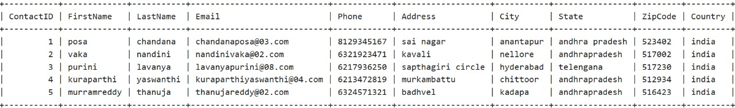

**2. Select Contacts from a Specific City:**

If you want to find contacts from a specific city, such as "Hyderabad":

SELECT * FROM Contacts

WHERE City = 'Hyderabad';

Output:



3. Count the Number of Contacts:

To count how many contacts are in the table:

SELECT COUNT(*) AS NumberOfContacts FROM Contacts;

Output:

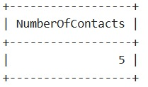

4. Select Contacts Ordered by ZipCode:

If you want to sort contacts by their ZipCode in ascending order

SELECT * FROM Contacts

ORDER BY ZipCode ASC;

Output:

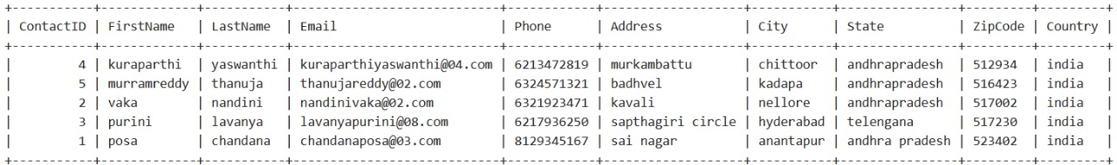

5. Search for Contacts by Partial Name Match:

If you want to find contacts whose first name contains "va":

SELECT * FROM Contacts

WHERE FirstName LIKE '%va%';

Output:



**For Leads:**

1.Select Leads from a Specific Source:

SELECT * FROM Leads

WHERE Source = 'Website';

Output:

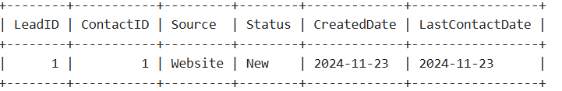

2. Count Leads by Status:

SELECT Status, COUNT(*) AS LeadCount

FROM Leads

GROUP BY Status;

Output:

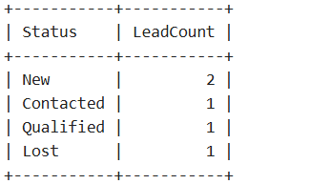

3.Find the Most Recently Created Lead:

SELECT * FROM Leads

ORDER BY CreatedDate DESC

LIMIT 1;

Output:

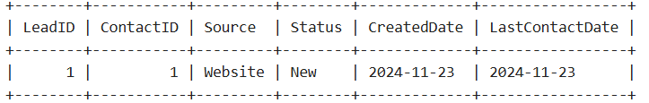

4.Retrieve Leads in a Specific Date Range:

SELECT * FROM Leads

WHERE CreatedDate BETWEEN '2024-11-20' AND '2024-11-23';

Output:

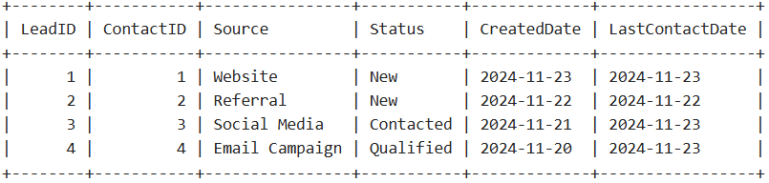

5.Get the Number of Leads Contacted in the Last 7 Days:

SELECT COUNT(*) AS LeadsContactedLast7Days

FROM Leads

WHERE LastContactDate >= CURDATE() - INTERVAL 7 DAY;

Output:

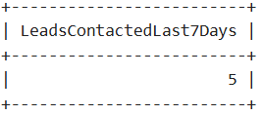

**For Opportunities:**

1.Select Opportunities with a Specific Stage:

SELECT * FROM Opportunity WHERE Stage = 'Proposal';

Output:

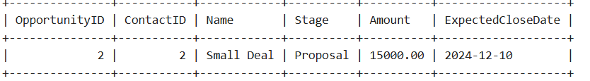

2.Select Opportunities with Amount Greater than a Specific Value:

SELECT * FROM Opportunity WHERE Amount > 30000.00;

Output:

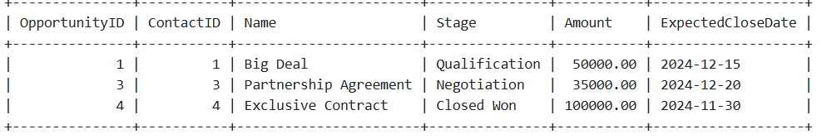

3.Count the Number of Opportunities by Stage:

SELECT Stage, COUNT(*) AS NumberOfOpportunities

FROM Opportunity

GROUP BY Stage;

Output:

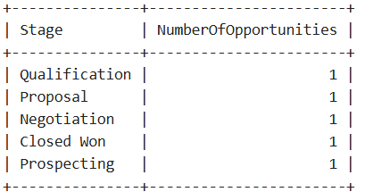

4.Find Opportunities Expected to Close in a Specific Month:

SELECT * FROM Opportunity

WHERE YEAR(ExpectedCloseDate) = 2024 AND MONTH(ExpectedCloseDate) = 12;

Output:

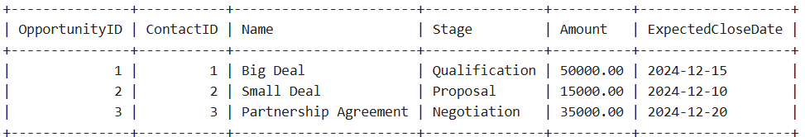

5.Select Opportunities with Future Expected Close Dates:

SELECT * FROM Opportunity

WHERE ExpectedCloseDate > CURDATE();

Output:

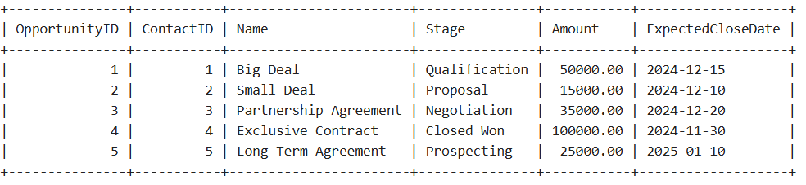

6.Find the Total Value of Opportunities in Each Stage:

SELECT Stage, SUM(Amount) AS TotalAmount

FROM Opportunity

GROUP BY Stage;

Output:

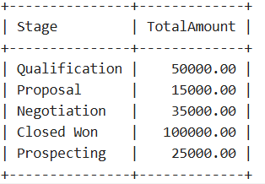

**For Activities:**

**1.**Find All Activities of a Specific Contact (e.g., ContactID = 1):

SELECT * FROM Activity WHERE ContactID = 1;

Output:

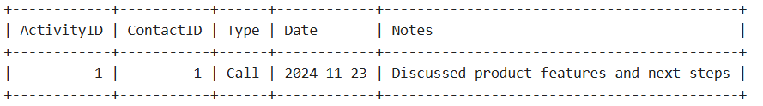

2.Count the Number of Activities per Contact:

SELECT ContactID, COUNT(*) AS ActivityCount

FROM Activity

GROUP BY ContactID;

Output:

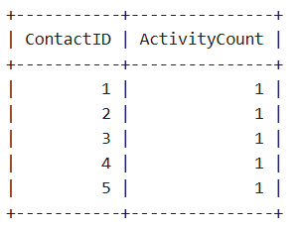

3.Find the Most Recent Activity for Each Contact:

SELECT ContactID, Type, Date, Notes

FROM Activity

WHERE (ContactID, Date) IN (

SELECT ContactID, MAX(Date)

FROM Activity

GROUP BY ContactID

);

Output:

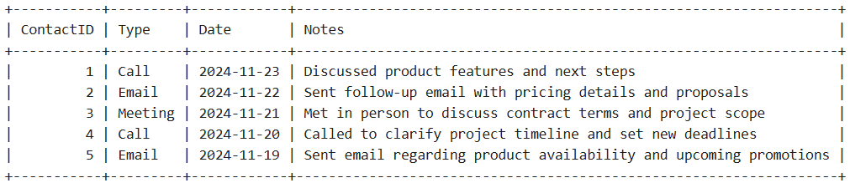

4.Get Activities within a Specific Date Range (e.g., '2024-11-20' to '2024-11-23'):

SELECT * FROM Activity WHERE Date BETWEEN '2024-11-20' AND '2024-11-23';

Output:

